Federal Deficit and Surplus
Student’s Name
Institutional Affiliation

Federal Deficit and Surplus
- Define Federal Deficit and Debt
Federal deficit refers to the amount by which the government’s expenditure in a year exceeds its total revenue in the same year. On the other hand, debt is the amount of total government borrowing in a given period of time.
- Graph 1: Using Fred data, prepare a graph for the Federal Surplus or Deficit [-]. Note that this graph is not be adjusted for inflation
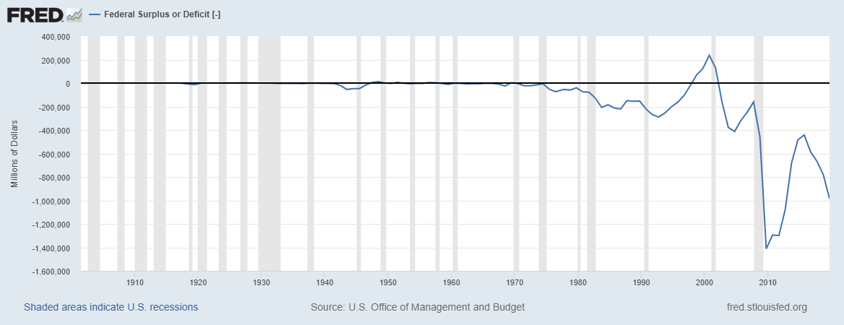
The above graph represents federal surplus or deficit against time from 1900 to the current era. During any year, government must make spending to through projects such as developing infrastructure, healthcare spending among others. Mostly what they spend is more than what they have collected as revenue so they end up with federal deficit like years betwee1980and 1995and years after 2002. Sometimes the government can spend less than the revenue collected hence ending up with federal surplus like years 1996 all the way to 2001. Some other time, the spending perfectly matches with the revenue as explained by years between 1910 and 1945.
Both recessions and expansions affect the graph differently. During the early years of the United States economy, i.e. 1900-1945, the recessions and expansions does not seem to have any effect to the spending and revenue collection of the federal government. For this reason, the graph remains straight and at point zero where expenditure equals the level revenue collected. However, afterwards the curve is seemed to go down steeply during recession and upwards gently during expansion.
In the year 1999, the level of country’s federal surplus hit the maximum of their history, this followed a great rise of the curve from above 200000 dollars’ federal deficit to 200000 dollars’ federal surplus. Some of the reasons for such improvements is that the federal government reduced its total expenditure and increased the amount of revenue collected every year. Another favorable condition that led to the massive rise is the absence of economic recession in the economy. Both fiscal and monetary policies were applied to ensure that the economy is stabilized.
During the economic recession that took place in the year 2009, the economy experienced one of the greatest downfall in which it went to lowest point ever in the history. This might have been caused by reduced revenue generated and a lot of resources used in development processes. Afterwards, the development policies for cure were applied and the economy recovered.
- Graph 2: Using Fred data, prepare a graph for the real Federal Surplus or Deficit that is adjusted for inflation
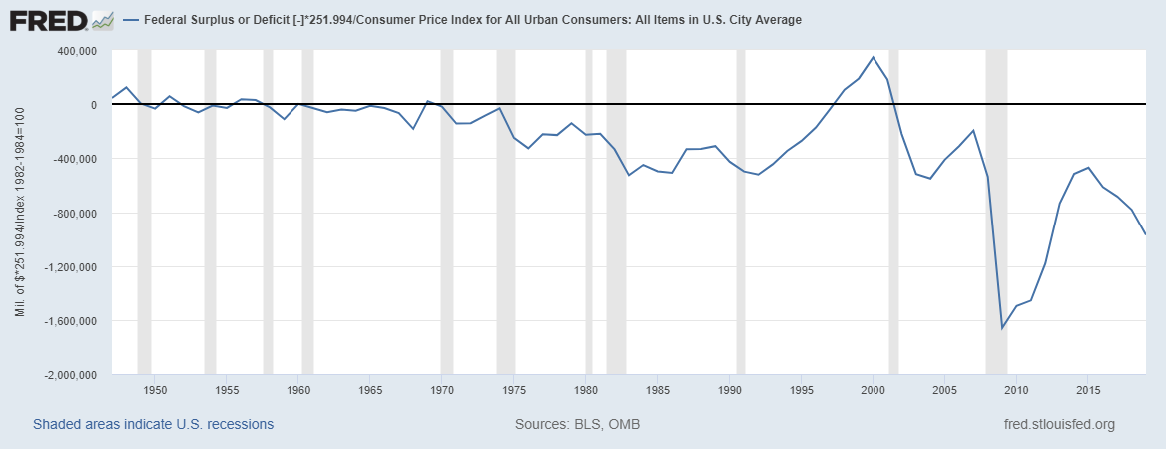
Inflation is sudden rise prices of goods and services in a certain economy over a certain period of time, mostly associated with devaluation of currency. Amount of resources that federal government spends in a year and that one which federal government collects in a year is greatly determined by the inflation rate (Navarro, 2019). Although there might be expected changes in the spending, the effect is almost the same. Increase in prices of commodities means that the government will tax more compared to the taxation before. Increased taxation leads to increased amount of resources gained. The cost of labor and commodities in the economy increases too which means that the government will spend more money to acquire the services would have otherwise achieved at a low cost in absence of inflation.
Upon introduction of inflation rate on the spending, the graph seems to change. This explains how inflation affects both the federal surplus and deficit. Rapid increase in prices of commodities reduces the money’s purchasing power and therefore results to increased spending which mostly leads to significantly small increase in federal deficit. Economically, inflation has negative effects on federal surplus and deficit on short-run and insignificant difference in the long-run.
Presence of inflation in any economy attracts efforts to cure it. Federal government therefore will install both expansionary and contractionary monetary and fiscal policies to cure inflation. Upon its cure, the rate of taxation will reduce which means that there will be decrease in total revenue by the federal government. There is reduced government spending which means federal surplus and deficit in both without inflation and with inflation lacks a significant difference (Chudik et al., 2018).
The graph of real Federal Surplus or Deficit that is adjusted for inflation greatly resembles that one of Federal Surplus or Deficit that is not be adjusted for inflation. The effect on recession and expansion are the same for the two graphs.
- Graph 3: Using Fred data, prepare a graph for the Federal Surplus or Deficit as a Percent of Gross Domestic Product
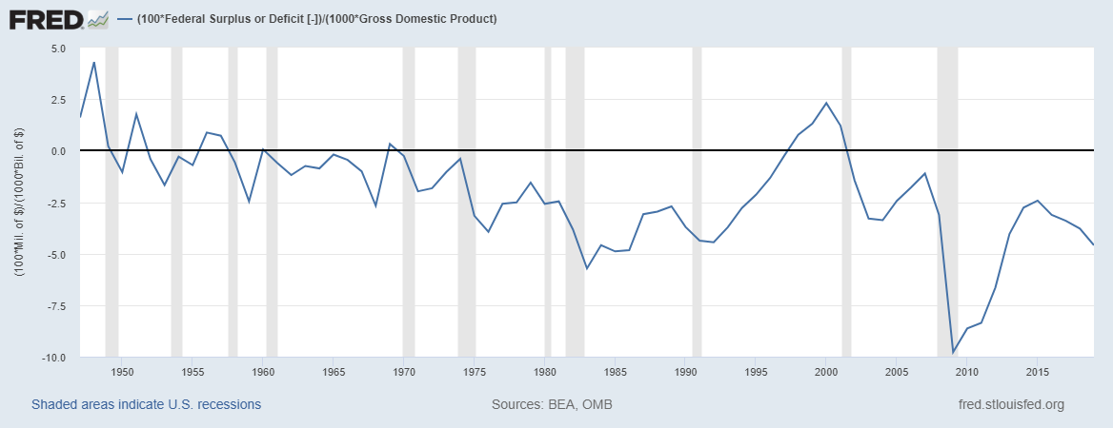
Federal government surplus and deficit are determined by how the government spend and collect its revenue, in other words, the difference between inlays and outlays. Gross domestic product is the total amount of commodities produced in an economy, mostly in one year. The American economy has been time to time altered by certain occurrences, sometimes experiencing a pick in the deficit curve and others a trough.
The American economy experienced the highest deficit peak of 5.7 percent during the years where world war existed, especially in World War II of 1939-1945. From time to time in the economy, deficit decrease was not a major occurrence. The federal government was able to perfectly heal the economy gradually 1959 when the situation was at their best after years of struggle. On afterward, the deficit curve would sway up and down the neutral point until 1992-2000 when the economy greatly improved. At this period, most Americans would give credit to economist and leadership who collaborated excellently to achieve this (Nguyen, Suardi & Chua, 2017). It must be noted that the economy experienced no recession during this time which could have favored the progress greatly.
After 2000, the economy was again affected negatively by prevailing conditions which include an economic recession in 2001. The economic downfall went all the way up to 2004 where it stagnated for rising a little bit few years later. There was a huge economic downfall in 2007-2008 economic year which saw the economy greatly affected negatively. By the end of 2010, the deficit percentage ratio to GNP had reached 10 percent which is the biggest ever downfall in the American economy. After 2010, new plans to awaken the economy were put forward by the federal government hence the deficit ratio started decreasing. In 2015, the ratio had reached 2.4 percent before it started deteriorating again years that followed. According to the current statistics, the deficit ratio had reached 4.6 by 2019.

- Graph 4: Using Fred data, prepare a graph for the Federal Debt: Total Public Debt as Percent of Gross Domestic Product
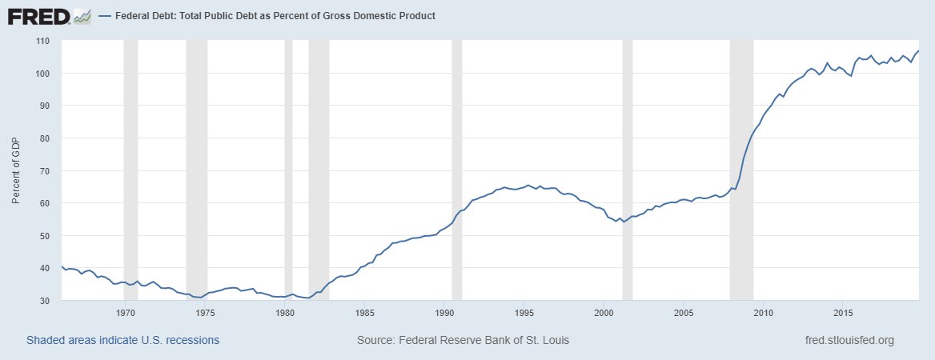
The above graph shows total public debt as percent of gross domestic product. Total public debt is the aggregate about of resources borrowed by the federal government from the public with an aim of funding its expenses in the economy. The amount is collected by means such as selling of public bonds and external borrowing, the money is refundable after a certain period of time, obviously at an advantage. Gross domestic product is the aggregate national production of goods and services in an economy. These two, are interrelated as shown by the above graph, a graph which moves from a very low point 40 percent, sometimes moving as low as almost zero and then rises up to a point above 100 percent in 2015.
Recession and expansions affects the graph differently. During recession, the graph is seen to be steeply rising at an increasing rate and at expansion, the graph rises and sometimes lowers at a significantly slower rate. The GNP ratio to public debt measure how the federal government is able to repay its debt. The lower the ratio, mostly measured in percentage, the better position is the government to repay the debt. In the USA economy, in 1975, the ratio was almost 30 percent at the lowest in the economy’s history which means that it was close to stability. Years after, the economy luckily strained up to 1981 when again the economy was close to stability.
Throughout the years from 1981, the condition of American economy worsened until today. In 2015, the value of the ratio reached triple figures percentages which even worse. It curves indicate that upon borrowing, the federal government will find it very hard to repay the debt. The World Bank stated in an official statement sometimes back that every time the GDP to public debt ratio exceeds 77 percent in any economy, that economy will find it very hard to repay the amount (Tymoigne, 2019). Recession of the economy seems to discourage the ability to pay back debt by the federal government.
- Where does the money come from? Using National Priorities Project website explain what are the main sources of revenues for the Federal government. Policy Basics: Where Do Federal Tax Revenues Come From?
The United States government spends billions of money every year. This money ought to have been collected from different sources with an aim of funding the national government’s activities of development. According to the available data, most of the government spending does not much what is collected. The following are some major sources of federal revenue, income taxes from individual, corporate taxes from businesses, payroll taxes and borrowings. Federal tax revenue comes from excise taxes, estate taxes, income taxes, and corporate taxes among others.
- What has happened to corporate taxes as percent of Federal Revenues over time?
According to National Priorities Project, the amount of federal revenue that the government used to collect as corporate taxes decline over a period of time up to currently six percent of total federal revenue collected. The decrease is due to loopholes in the process of taxations mostly expressed by multinational companies, which allocated profits to overseas branches to avoid much taxation.
- Where does the money go? Using National Priorities Project website explain the federal spending? What is discretionary and mandatory spending?
The government of United States spends it resources in three different ways, mandatory spending and discretionary spending which takes more than ninety percent of total federal revenue and the third type is interest on debt. Mandatory spending is what the congress allows to be spend outside appropriations process. It comprises appropriately two-thirds of total federal revenue and it includes social securities and Medicare among others. Discretionary spending comprises is what the Congress legislates through an appropriation process, they include military, education, energy among others.
References
Chudik, A., Mohaddes, K., Pesaran, M. H., & Raissi, M. (2018). Rising public debt to GDP can harm economic growth. Economic Letter, 13(3), 1-4.
Navarro, R. S. (2019). Fiscal Imbalances, Inflation and Sovereign Default Dynamics. Ensayos de Política Económica, 1(4), 108-142.
Nguyen, T. D., Suardi, S., & Chua, C. L. (2017). The behavior of US public debt and deficits during the global financial crisis. Contemporary Economic Policy, 35(1), 201-215.
Tymoigne, E. (2019). Debunking the Public Debt and Deficit Rhetoric. Challenge, 62(5), 281-298.

